Linear Algebra

Laboratory Activity No. 10

**Linear Transformations**

*Submitted by: Instructor:*

Parco, Jovian Asher G. Engr. Dylan Josh D. Lopez

December 22, 2020

# Objectives

This laboratory activity aims to visualize matrix operations, roles of matrix operations, and visualizing linear transformations.

# Methods

In this laboratory activity, the practices consist of visualizing linear transformations using Python and The Numpy with conjunction Matplotlib, where the Numpy uses the array() function to declare a matrix. At the same time, Matplotlib is a way to visualize the matrix, which is the linear transformation.

# Results

The complete repository for the activity is available at Github (http://bit.ly/34BoszL). For the final lab activity, the researcher must create or try to implement linear transformation using the span scatterplot view.

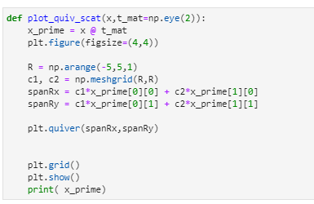

Figure Function for the implementation of the linear transformation

For the lab activity, the researcher created a function (Figure 1) where there are two parameters where must be a matrix. At the same time, the other one is set to Numpy.eye() as the default wherein can create diagonal one while zeros on sides, the next line declared another value by the dot product of the parameters, the researcher uses the last lab activities for the basis of the function where creates a plot. The creates the equation for the span and use the quiver() function to show the span.

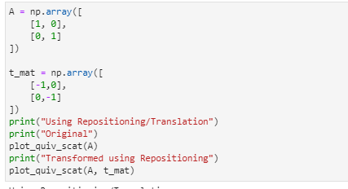

Figure Inputted coded for the function

The researcher decided to input (Figure 2) repositioning or the Translation linear transformation for ease of explanation, where “A” can be plotted and will equal to 90 degrees while “t_mat” will equal to 180 degrees which are the opposite, it should show us the flipped position if the matrices run thru the transformation function.

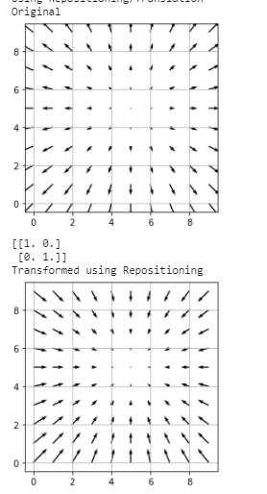

Figure Output for the Inputted code

As the researcher predicted the arrows flipped (Figure 3) because the plot platform is changed not the arrow itself, it is the manipulation of the plot that’s why the arrows moved.

# Conclusion

To visualized linear transformation it should be view on the third dimension because its easier to see the manipulation of the plot where it conforms to the linear equations, linear transformation can be useful in mechanics because it can show models that can be replicated in the real world like a wind current the behaviour of it when inside of a building or tunnel.**References**

[1] “Linear Transformations.” https://textbooks.math.gatech.edu/ila/linear-transformations.html (accessed Dec. 23, 2020).

[2] Y. Cui, J. Qu, and G. Zhou, “Application of linear transformation in numerical calculation,” Available online www.jocpr.com J. Chem. Pharm. Res., vol. 6, no. 3, pp. 170–178, 2014, Accessed: Dec. 23, 2020. [Online]. Available: www.jocpr.com.

[3] “Linear transformations and matrices | Essence of linear algebra, chapter 3 - YouTube.” https://www.youtube.com/watch?v=kYB8IZa5AuE (accessed Dec. 23, 2020).

[4] K. Datta, Y. Hong, and R. Baik Lee, “Applications of linear transformations to matrix equations,” Linear Algebra Appl., vol. 267, pp. 221–240, Dec. 1997, doi: 10.1016/s0024-3795(97)80051-1.